**SQS Quality Assurance:**

**Enhancing the training web application**

Team 6

October 2, 2017

Jake Davis

Dylan Jenkins

Binod Katwal

Manni Mashaee

Customer: SQS

**Table of Contents**

**Architecture Diagram** **2**

**Detailed Design** **4**

User Interface Design 5

**Testing** **9**

**Quality Assurance** **10**

**Metrics** **1**1

Complexity of overall system 11

Product size 11

Product effort 11

Defects 11

# 

**Architecture Diagram**

All components of the stack interact with each other to provide the required functionality of our website. Looking at **Figure 2**, The five components are: front-end(HTML/CSS/Javascript), back-end(PHP), Apache Web Server, Web Application, and the MySQL database. When a user initially types the url of our website a request is sent from their browser to the Apache Web Server for the website home page and because PHP is used in the website’s code, the server will turn over the request to the PHP module, which reads the PHP and replaces the code with the output it generated back into the page, and outputs it onto the browser. Three levels of users will be allowed on the website: guest, employee and admin. Each user type will have a different user interface and access to different types of data.

User’s will first be routed to website home page, and be asked the sign up or sign in, if not signed in, the signup process will begin by asking the user for the required information. Otherwise the user will login and send a request to the Apache Web Server in an attempt to be authenticated from the MySQL database. If the credentials provided are valid, a response will be sent back authorizing the user and sending the appropriate page requested from the database back to the server and displayed to the browser. If the credentials are not valid, the user will not be authorized and the requested page will not be sent. After authentication, based on the credentials entered the appropriate page will be served. If valid admin credentials were entered the page served will be the admin page which is the only page where you can edit other user’s information, otherwise, the user home page will be served.

Figure 1: Architecture Diagram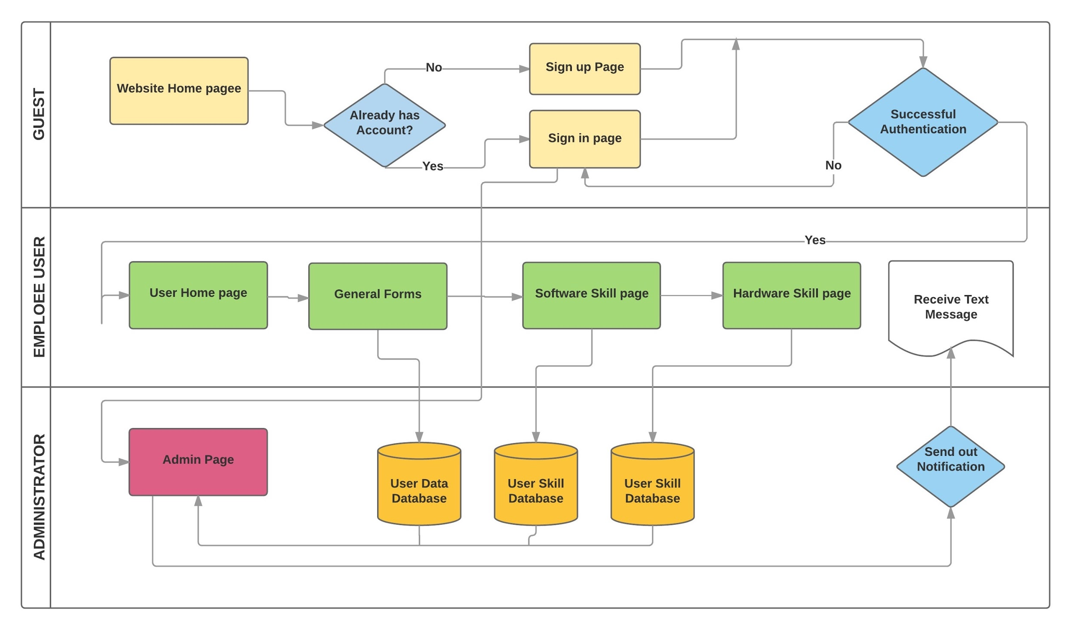

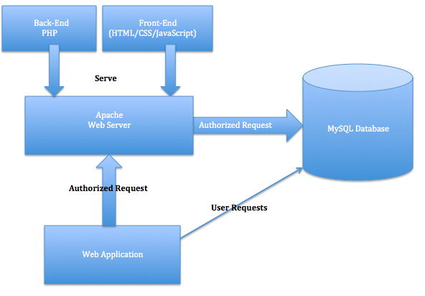

Figure 2: Architecture Diagram

**Detailed Design**

Figure 3: Class Di agram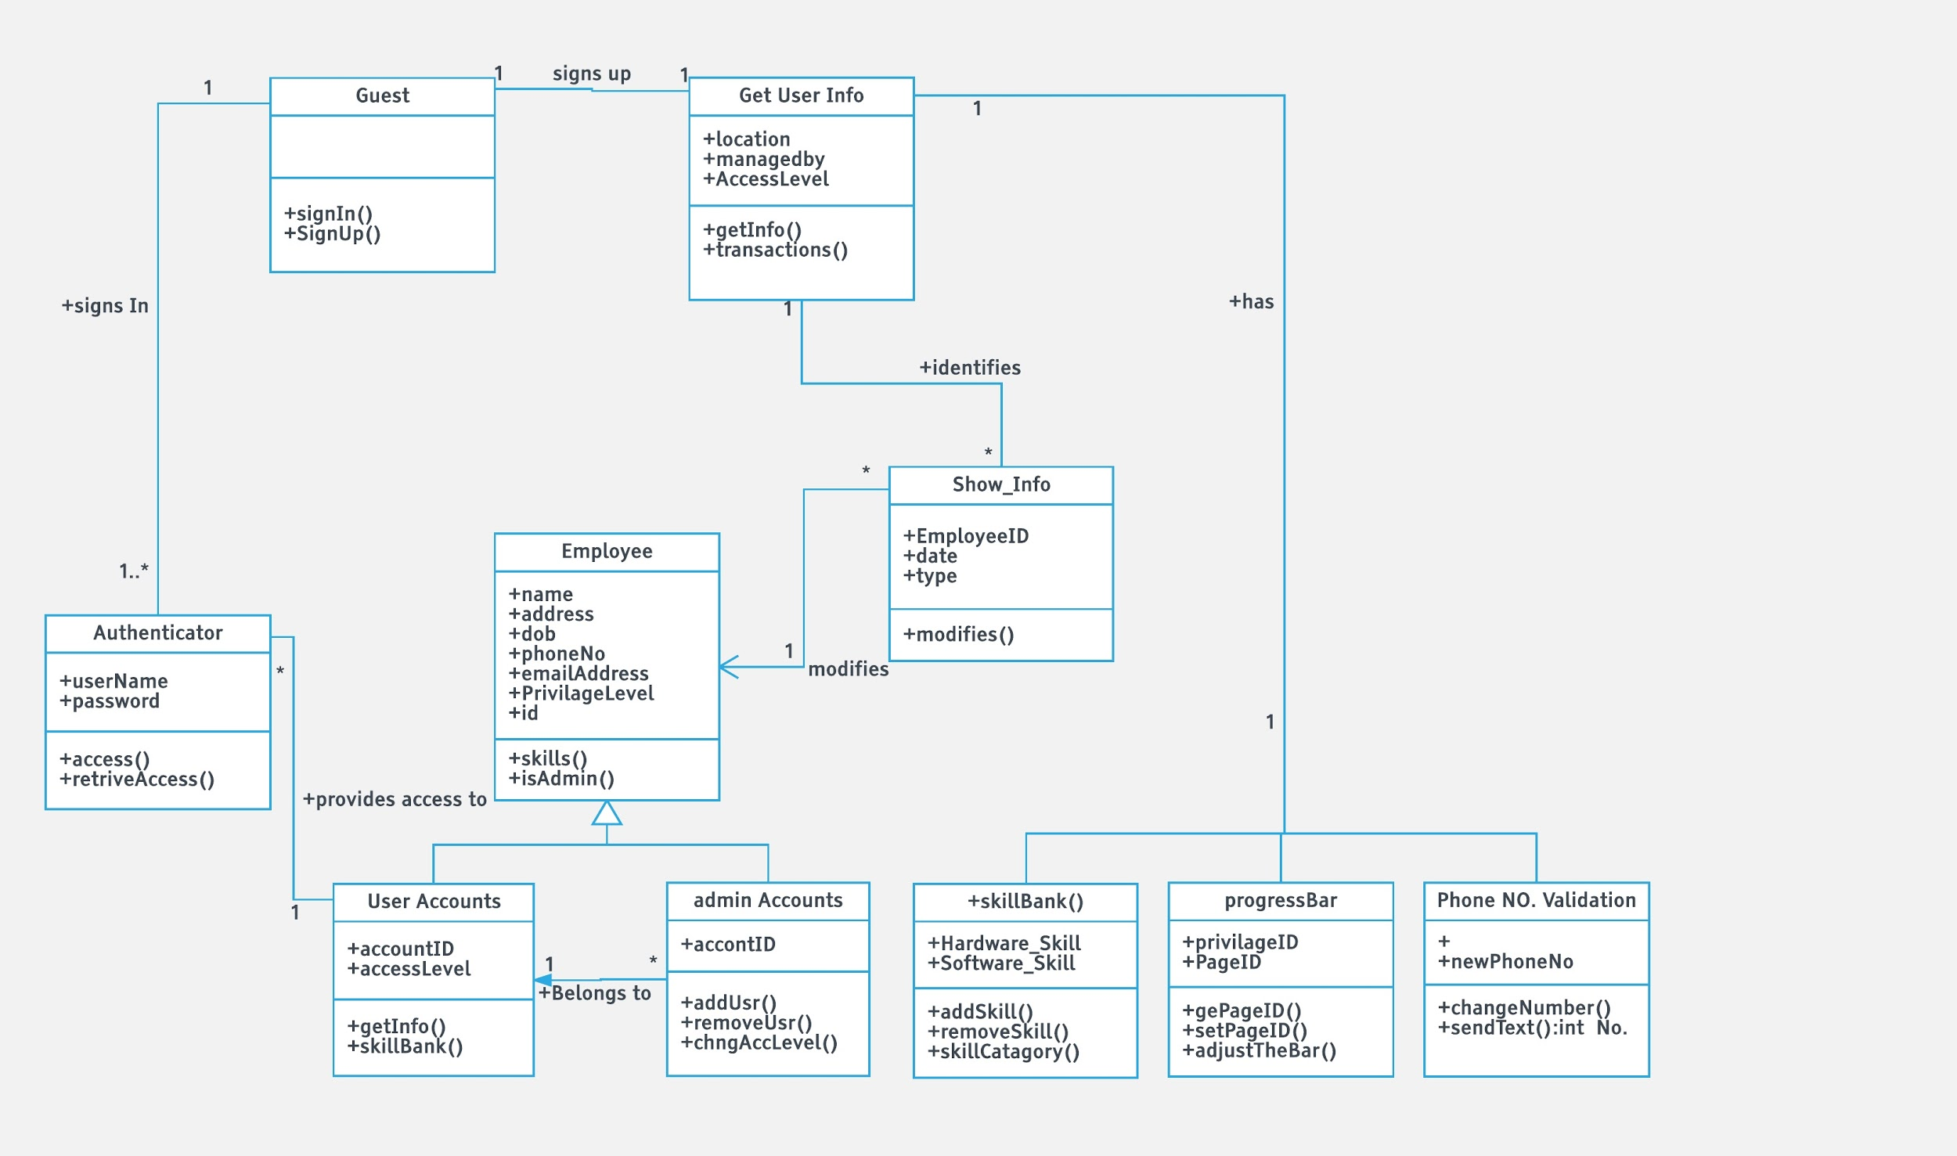

* **ProgressBar Class**
* **SkillBank Class**
* **Authenticator Class**
* **Show_Info Class**

User Interface Design

The web application SQS has provided has a lot going on behind the scenes. Thus, they designed the interface of the web application to be as easy as can be. Below are some images that show the general layout of the web application and all its features. The first is the home page where no user has signed in.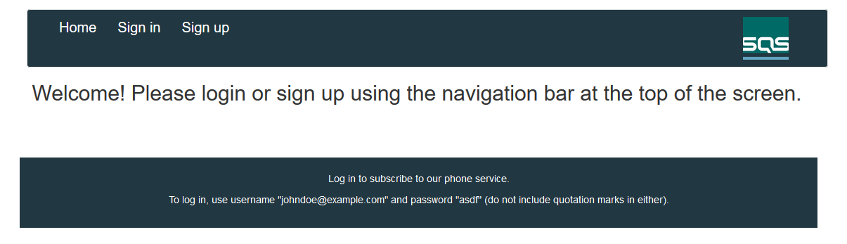

For this page, the user really only has a couple options. Either to sign in or sign up. If the user decides to sign up they will be directed to the page below. Otherwise Signing in will direct them to a page asking for their email and password. Then redirecting them to the homepage after signing in which may also be seen on the next page.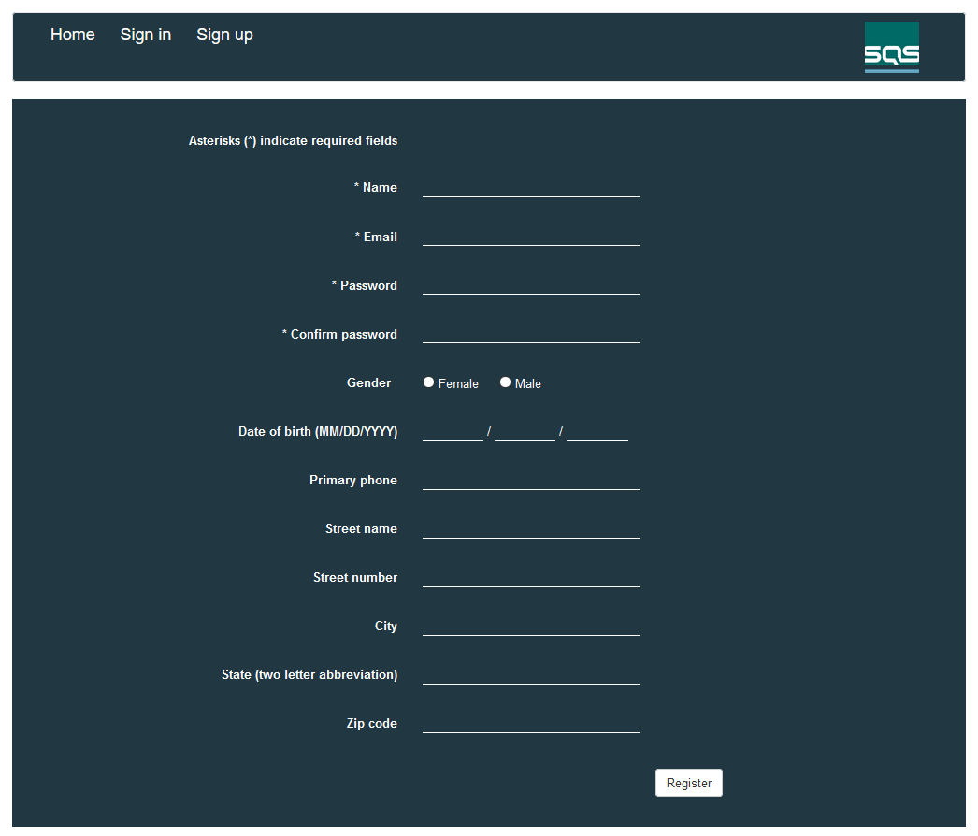

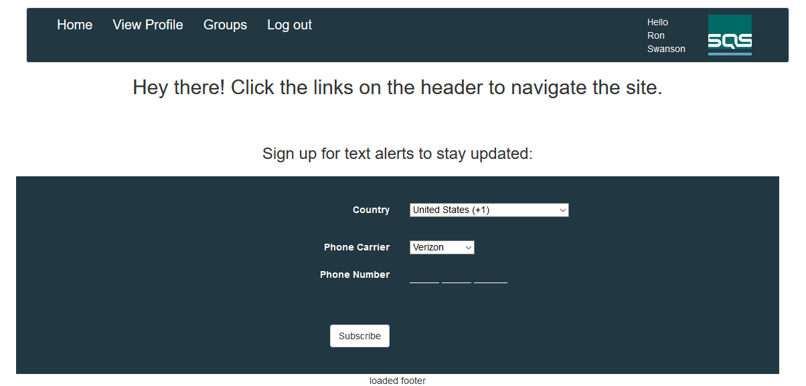

Once the user has signed in they may subscribe to the phone listings. This simply adds the user to the subscribers table in the database. From here the user may click View Profile to view their profile which displays all the information the user has submitted to the database or the user may click Groups which directs them to a page that displays all active groups and their group leaders.

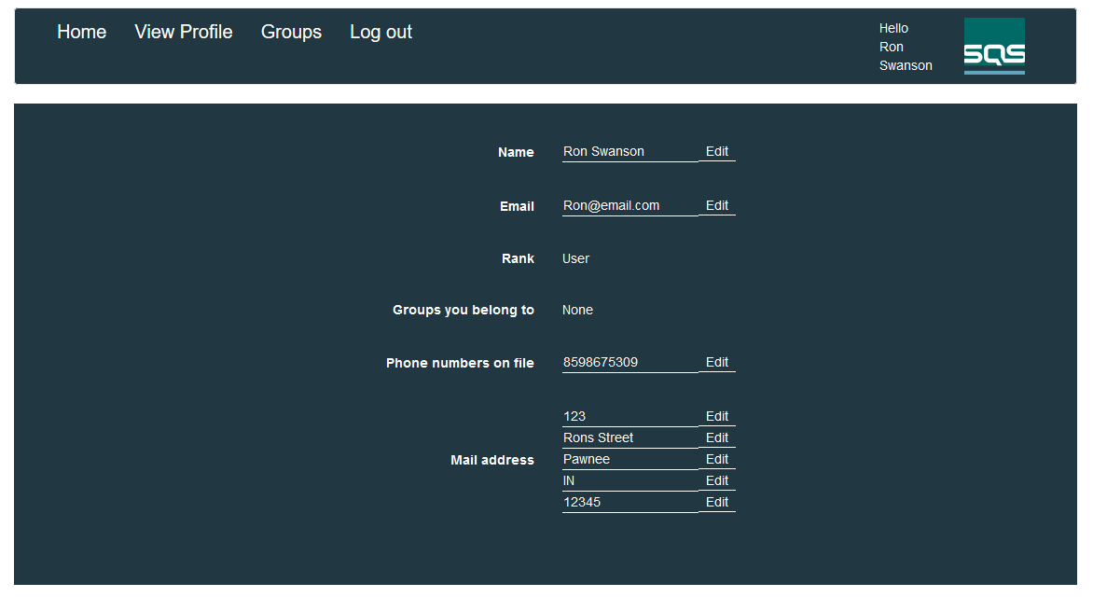

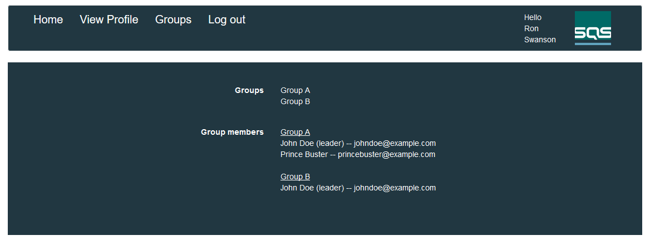

Finally there needs to be a difference between the privileges of users. So there is a regular user, a superuser, and an admin. A regular user has all the privileges shown so far, a superuser and an admin will have an additional link to a page that allows them to edit groups. However, a superuser may only edit the groups. An admin has the ability to edit groups and group leaders. Due to their similarity only the admin page is shown below.

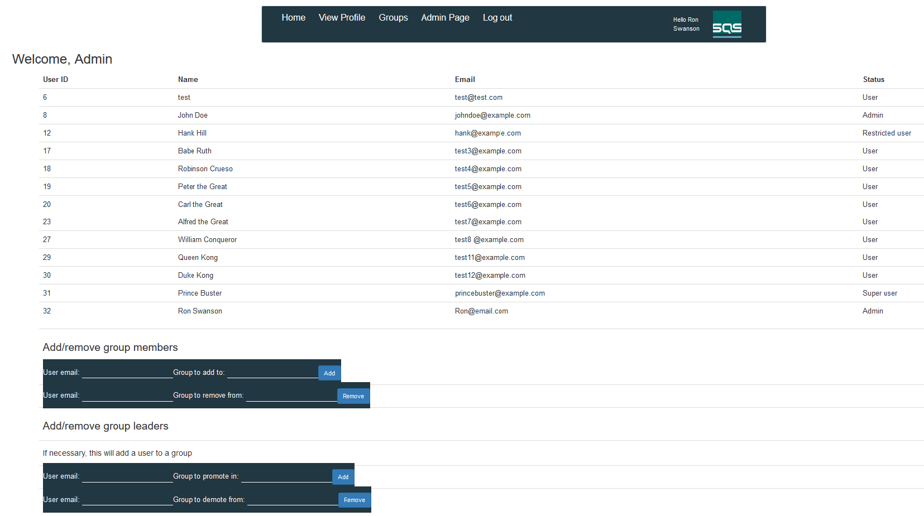

The interface for the database itself will really vary pending on the desired method of setup. Currently are using XAMPP and phpMyAdmin. Alas, within the database there needs to be 11 tables. The sql statements to create the tables were provided. The tables needed are assigned_features, email_list, features_availbale, groups, group_members, levels, level_privileges, mail_address, phone_list, privilege_list, subscriber, and user.

# Testing

**Test Test Case Success Condition Fail condition**

|  |  |  |  |
| --- | --- | --- | --- |
| 1 | Valid new user sign up.  *Required information check* | User account created in the database. | User account creation unsuccessful and error is displayed. |
| 1b | Invalid new user sign up.  *Required Information:*  *Passwords don’t match* | User account creation unsuccessful and error is displayed. | User account creation successful. |
| 1c | Invalid new user sign up.  *Required Information:*  *Email in use* | User account creation unsuccessful and error is displayed. | User account creation successful. |
| 2 | Valid user sign in. | User login successful.  Redirected to home page. | User login unsuccessful. |
| 2b | Invalid user sign in. | User login unsuccessful.  Error displayed. | User login successful. |
| 3 | Address information submission | User address information in the database. Visible on user profile. | Address information not found in database or on user profile. |
| 4 | Hardware skills submission | User hardware skills in the database. Visible on user profile. | Hardware skills not found in database or on user profile. |
| 5 | Software skills submission | User software skills in the database. Visible on user profile. | Software skills not found in database or on user profile. |
| 6 | User update’s hardware skills. | Updated hardware skills in the database and on user profile. | User skills unsuccessfully updated in the database and/or on user profile. |
| 6b | User update’s software skills. | Updated software skills in the database and on user profile. | User skills unsuccessfully updated in the database and/or on user profile. |
| 7 | Progress bar update. | The progress bar updates according to where the user is in registration process. Forwards or backwards. | Progress bar does not update or does not appear. |
| 8 | Registration process cookies | User information is retained on the pages during registration process. | User information is not retained. |

# **Quality Assurance**

With the quality assurance review in mind, a personalized checklist was devised for the product system. The checklist, found below, was used in confirming that the overall architecture and each section of the document met all the necessary specifications required by the assignment prompt.

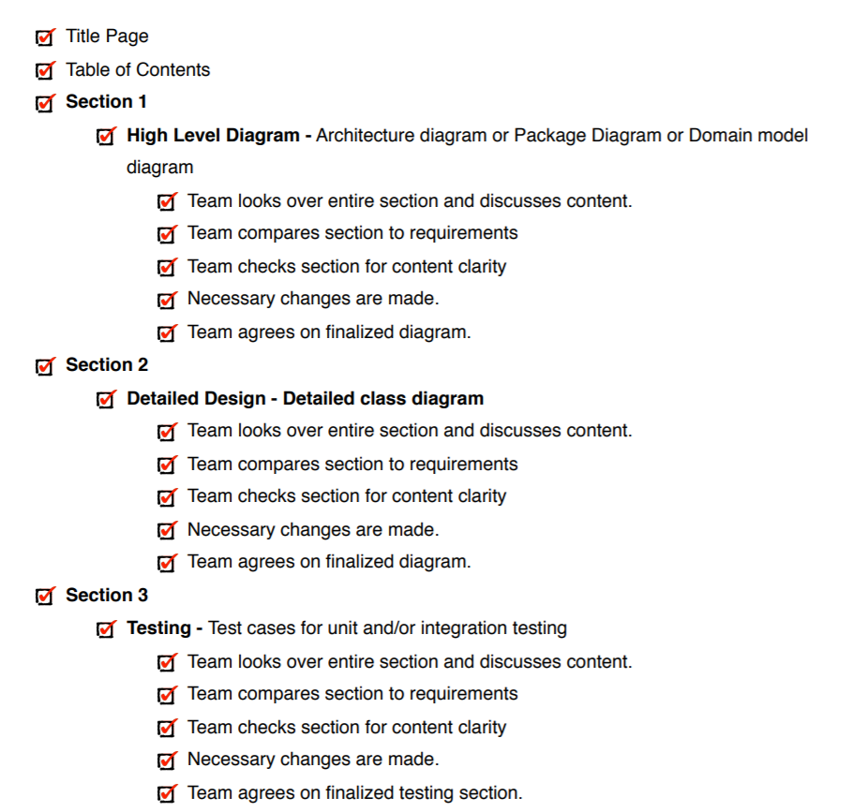

# **Metrics**

## **Complexity of overall system**

This system does not have inheritance due to the nature of Javascript, html, and php. With no classes or objects there is a lack of an object oriented infrastructure. Coupling between classes is also not applicable since none in our system depend on the other.

## **Product size**

SQS has given us seven features with 29 story points and a total of 12 unit test cases.

## **Product effort**

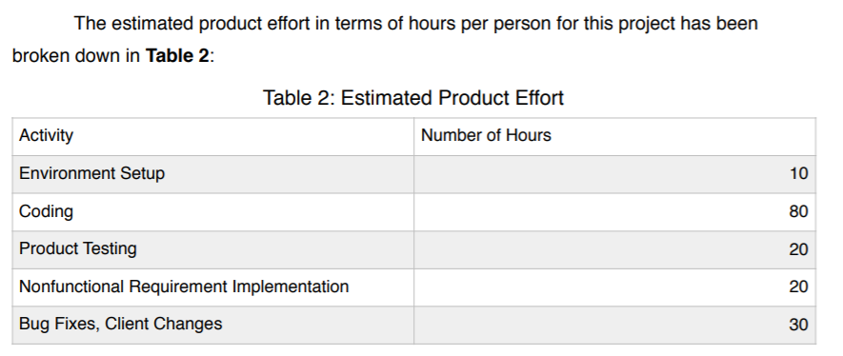

## **Defects**

As coding work on the project has not been started yet, no defects have been discovered. No relevant defects were found in **Sections 1-3** of this document.